

**Beaver Sleepover 2025**

We are excited to invite your child to the 1st New Longton Beaver Sleepover as part of our Group Christmas Camp.

**When?** 10.30am Saturday 4th January to 10.00am Sunday 5th January 2025

**Where?** Fylde Scout Activity Centre, Heyhouses Ln, Lytham Saint Annes FY8 3RN

**How much?** £30.00

**What will we be doing?** A variety of outdoor activities, playing games and craft activities.

**The children will be fed over the course of the weekend. We will provide lunch and dinner on the Saturday and breakfast on the Sunday. We kindly ask that your child does not bring any food with them other than a single bag of sweets (for midnight snacks!)**

To confirm your child’s place, please complete the form by following the below link and make payments to:

<https://forms.office.com/r/KqfRJEvyE0>

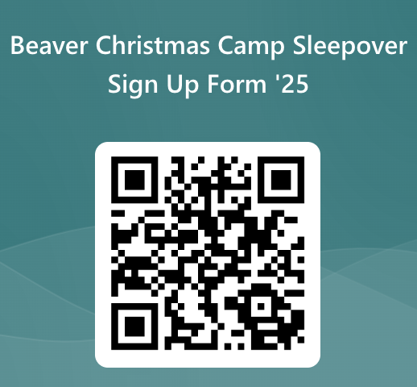

Please complete this form by **Thursday 12th December 2024**.

If you have any questions or would like more information, please see Sarah or Rebecca.

**More detail:**

**Getting there:** All members will be required to make their own way to and from the sleepover.

**Adults on site**: All adults on site will have a suitable DBS check, be registered with the Scout Association and have completed or in process of completing relevant training.

**Kit List:** Attached is a kit list that each person will need to bring with them. If your child has any food intolerances or allergies, please make sure that this is clear on the online medical form.

**Medications**: If your child requires any medication, it should be clearly labelled and handed to the camp leader at the start of camp. If your child usually takes any regular medication, please ensure this medication comes to camp with your child.

**Cleaning/washing facilities**: There are toilets and basic washing facilities only on this sleepover. There will be no need for the children to shower on this event.

**Electronic devices:** No electronic devices are allowed on this sleepover, this includes mobile phones and game consoles. Should your child need to get in contact with you or you need to speak to your child, a mobile phone number will be available during the event:

**Kit List**

*Please use this kit list as a guide and feel free to alter based on your child’s needs and time of year - please remember even in the summer it can get cold at night.*

**No electronic devices including mobile phones. No food other than a single bag of sweets.**

**Please label all items with your child’s name.**

**▢** Full uniform, including necker and woggle

**▢** Sleeping bag

**▢** Pillow

**▢** 2 changes of clothes

**▢** Waterproof trousers

**▢** Waterproof jacket

**▢** Suitable outdoor footwear

**▢** Alternative footwear for indoor use

**▢** Warm jumper/hoodie

**▢** Pyjamas

**▢** Toiletries

**▢** Towel

**▢** Torch and spare batteries (not essential)

**▢** Drinks bottle (refillable)

**▢** Teddy bear or something from home

**If you have any issues getting any of the items on the list, please let Sarah or Rebecca know and they should be able to direct you.**